For a dog to be listed on our website the registered owner must be a current financial member of Labrador Retriever Club of WA Inc. A member may have up to 6 dogs listed for a total fee of $20 which is due annually with membership renewal.
The Labrador Retriever Club of WA Inc. takes no responsibility for any transactions that may occur by interacting with those on the Stud Dog List.
The owners are all members of Dogs West and must comply with the minimum standards for breeding Labrador Retrievers.
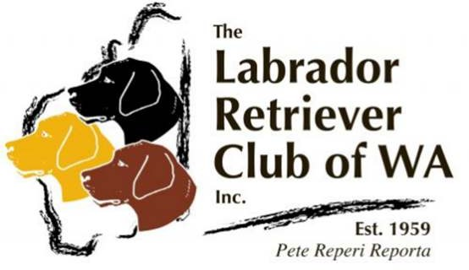

Stud Dog Listing Form
Please complete one form per dog
Category of availability to approved bitches:
- Fresh or Chilled Semen or a Natural Mating
- Frozen semen only
Dog’s Name
Dog’s Registered Name followed by Pet name in brackets
Dog’s DOB / /
Dog’s Colour
Dog’s phenotype and the colours he carries, if any
Dog’s Sire
Dog’s Dam
Dog’s Hip Score Dog’s Elbow Score
Left : Right Left : Right
Dog’s DNA
Clear or Carrier of or Affected by
Contact Name
Contact email
Dogs West Member No.:
Signed ______________________________ Date ________________________
Payment Details: $20 annual fee
Payment Methods: Bank Transfer (Please include Name), Cash or Cheque.
Account Name: Labrador Retriever Club of WA BSB: 066 108 Account No.: 0090 4068
Please return your completed form to Linda Foster (Secretary)
via email caranthar@optusnet.com.au and your details will be uploaded to our website

