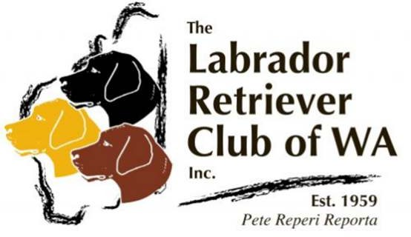

Breeder Listing Form
Only financial members of the Labrador Retriever Club of WA Inc. who reside in Western Australia and are current members of Dogs West [CAWA] may appear on our breeders list. Breeders are bound by Dogs West Regulations – Section H – Codes of Ethics and uphold all standards with the National Breed Council.

Prefix
Membership No. Short Blurb
About your kennel
Contact Name
Contact No.
Email Website
Suburb

Signed Date

Please return your completed form to Linda Foster (Secretary)
via email caranthar@optusnet.com.au

and your details will be uploaded to our website

